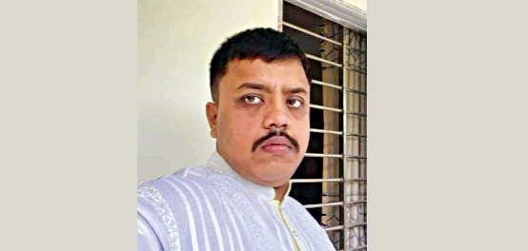**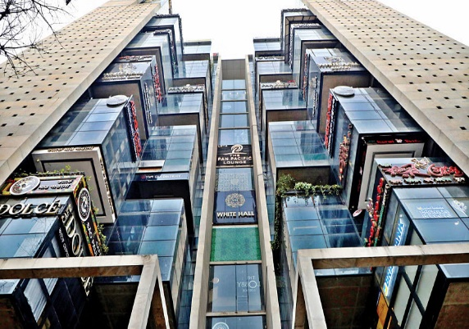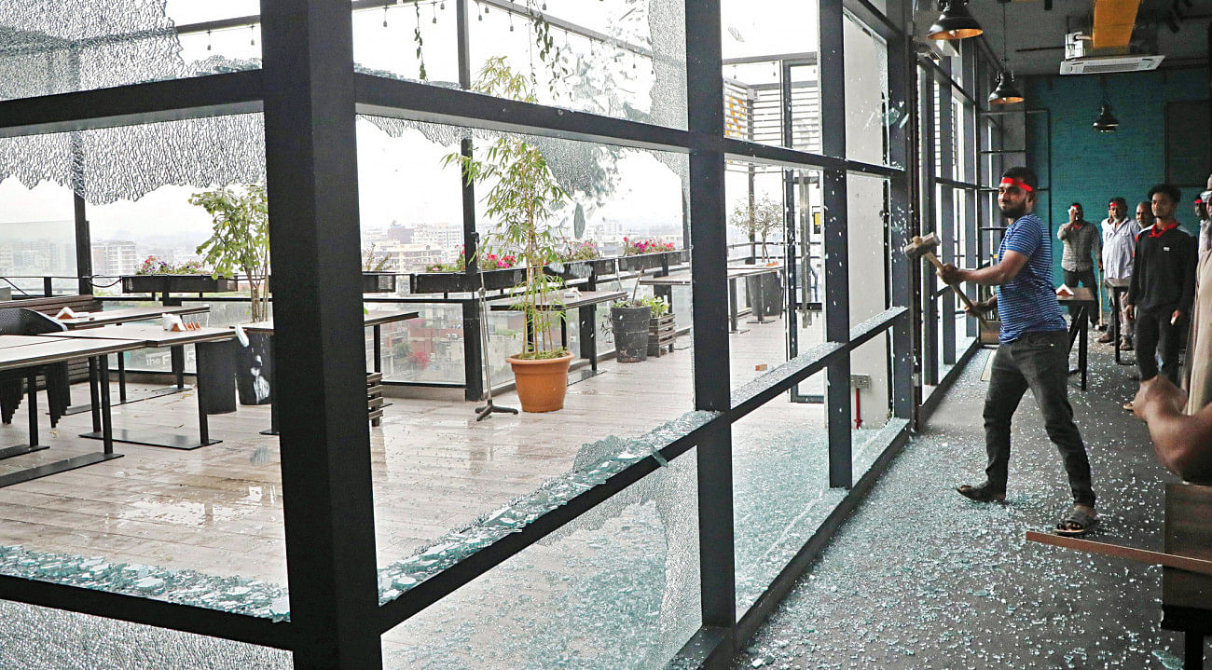sP7** 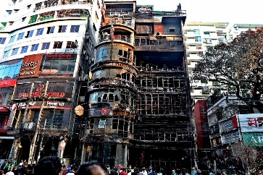

SIRAJGANJ MEDICAL COLLEGE

**And just like**

**That, teacher**

**Shoots student**

**OUR CORRESPONDENT**,*Pabna*

**RIFATULLAH MIRDHA**

Exports crossed the $5 billion-mark for the third month in a row.

In February, in yet another bright spark for the economy battling a persistent strain on the dollar stockpile.

In February, exports brought home $5.18 billion, up 12.04 percent from a year earlier, according to data from the Export Promotion Bureau.

The strong showing was led by garment exports, which fetched about 14 percent more at $4.5 billion last month.

"That is one of the highest monthly receipts," said Faruque Hassan, president of the Bangladesh Garment Manufacturers and Exporters Association.

Export cross $5b for

third month in a row

Some had fire exits obstructed.

The three-storey Gausia Market, with over 315 shops, has seven staircases for entries and exits, but those were obstructed by piles of clothes at places.

The fire service classified the market as "highly risky" in 2020 and then again in April 2023 as it lacked fire hydrants and an inadequate water reserve.

Rafiqul Islam, a leader of the Gausia Market Shop Owners' Association, claimed that they now have enough water in reserve and wider staircases. He said the market was only "highly risky" as it stores flammable materials.

On the piles of clothes in the staircases, he told The Daily Star, "It happens as shop owners bring in extra clothes ahead of Eid." They would be removed soon and more fire extinguisher would be placed, he added.

“Highly risky” Rajdhani Supermarker

**SEE PAGE 2 COL 4**

**DIPANNANDY *and* MOHAMMAD JAMIL KHAN**

Three in four markets and shopping arcades in Dhaka city lack proper fire safety measures, according to a Fire Service and Civil Defence inspection report.

The fire service inspected 58 markets and shopping arcades last year and found nine of them to be "highly risky" and 35 "risky".

The fire service classifies "highly risky" or "risky" structures based on criteria, like the number of staircases for entries and exits, space in staircases, the number of fire extinguishers present, availability of fire hydrants, and the capacity of water reservoirs .

“This is dangerous. However, awareness and coordinated enforcement efforts to ensure fire safety can improve the situation," Brig Gen Md Main Uddin, director general of the fire service, told The Daily Star.

He claimed that the risky establishments did not follow the Bangladesh National Building Code.

**3 out of 4 city**

**markets risky**

destinations like Europe and the US are on the decline, he said..

Moreover, exports to non-traditional markets like Japan, India, Russia, South Korea, Brazil, Argentina, Turkey, South Africa, Australia and China are on the rise, Hassan added.

February's receipts take the total earnings from garment shipments in the first eight months of the fiscal year to $32.9 billion, up 4.8 percent year-on-year but missing the export target by 5.2 percent.

Similarly, overall export receipts of $38.5 billion during the period were 3.7 percent from a year earlier but fell short of the periodic target by 6.5 percent.

Apart from goods, jute and jute goods,

**SEE PAGE 2 COL 1**

Remittance inflows soared 39 percent in February to $2.16 billion, the highest in eight months, to take the tally to $15.06 billion.

As of February 28, foreign exchange reserves stood at $20.57 billion, enough to meet about three months' import bills, according to the latest published data by the Bangladesh Bank.

Students and teachers alleged that Rayhan Sharif, a teacher of the college's Community Medicine Department, often carries a gun on the college campus and yesterday he opened fire during the exam around 3:0

**SEE PAGE 2 COL 3**

**STAF CORRESPONDENT**

Rajuk yesterday conducted a raid in the Gawsia Twin Peak building on Dhanmondi's Satmasjid Road and sealed off 12 restaurants there, four days after a deadly fire in a Bailey Road building killed at least 46 people.

In a separate drive, Dhaka South City Co

**SEE PAGE 2 COL 4**

**INADEQUATE FIRE SAFETY MEASURES**

Arafat Amin Tamal, a third-year student, was admitted to the college hospital with a bullet wound in his right thigh, police said.

A teacher shot and injured a student during a viva at Shaheed M Monsur Ali Medical College in Sirajganj yesterday afternoon.

**The rooftop restaurant in the Gawsia Twin Peak tower, on the capital’s Satmasjid Road, being demolished during a drive by Rajuk authorities yesterday. The drive was conducted as the building was constructed for offices and not for housing restaurants**.

PHOTO**: PRABIR DAS**

**FIRE HAZARDS**

Agencies springinto action, finally

**Rajuk, DSCC,DMP carry out drives in capital;12 restuarent, commercial building sealed off**

**P10**

**P80**

**P70**

**Ending locker room talk at**

**The workplace**

**Why do**

**Authorities gamble with**

**With our lives?**

**P8**

**China violating**

**‘Fundamental**

**Rights’ in**

**Xinjang, Tibet**

**P7**



**YOUR RIGHT**

**TO KNOW**



**DHAKA TUESDAY MARCH 5, 2024**

**REGD. NO. DA 781 VOL.XXIV NO. 51 FALGUN 21, 1430 BS** [**WWW.the dailystar.net**](http://www.thedailystar.net/)  **SHABAN 23, 1445 HIJRI 16 PAGES PLUS LIFE STYLE : TK 15.00**